Protocol for Treating Musculoskeletal Disorders (MSDs) Using Low-Intensity Shockwaves
Device: MoreNova DT, MoreNova Pro with C30 and C15 Transducers.
Document Version: 2.0
Date: 17/12/25
1. Purpose and Scope
This protocol provides a standardized treatment plan for using low-intensity shockwaves to
manage musculoskeletal disorders (MSDs), including chronic pain, tendinopathies,
myofascial trigger points, and musculoskeletal injuries. It is intended for healthcare
providers using the MoreNova Device with the C30/C15 Transducers to target affected
muscle and tendon regions. This protocol applies to patients aged 18–80 years diagnosed
with MSDs, including but not limited to:
•
•
•
•
•
•
Tendinitis (e.g., Achilles tendinitis, rotator cuff tendinitis)
Myofascial pain syndrome
Chronic lower back pain
Osteoarthritis-related pain
Plantar fasciitis
Post-injury rehabilitation
2. Introduction
MSDs are among the leading causes of disability and pain worldwide. Traditional treatments
such as physical therapy, medications, and surgical interventions may have limitations. Low -
Intensity Extracorporeal Shockwave Therapy (LiESWT) provides a non-invasive approach that
enhances healing by promoting angiogenesis, reducing inflammation, and stimulating
cellular regeneration in affected tissues.
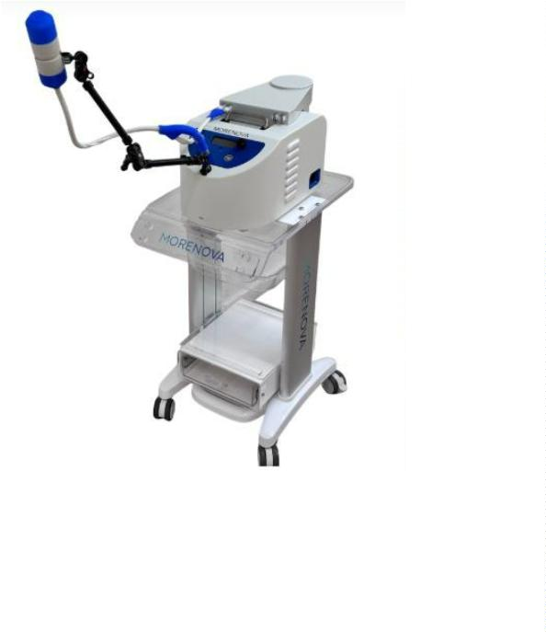

3. Scientific Review
Current Treatments:
•
•
•
Drug therapy: NSAIDs and corticosteroid injections provide symptomatic relief
but do not address underlying causes.
Physical therapy: Effective for muscle strengthening and mobility but may
have limited impact on chronic conditions.
Surgery: Reserved for severe cases but involves longer recovery and potential
complications.
Advantages of LiESWT:
•
•
•
Non-invasive and painless procedure with no significant complications.
Promotes angiogenesis and enhances tissue repair.
Reduces musculoskeletal pain by improving microcirculation and modulating
inflammatory responses.
•
Effective in treating chronic conditions resistant to conventional therapies.
4. Patient Selection Criteria
Inclusion Criteria:
1.
2.
3.
Adults (18–80 years) diagnosed with MSDs.
Persistent symptoms for at least 3 months despite conservative treatment.
Patients with tendinopathies, myofascial pain, or post-injury musculoskeletal pain.
Exclusion Criteria:
1. Implants and Electronic Devices
Active Electronic Implants: Pacemakers, Cardioverters, Defibrillators, or Neurostimulators.
Metallic Implants: Any metallic or orthopedic implants (screws, needles, etc.) in or near the
treatment area.
2. Malignancy and Cancer History
Active Cancer: Known or suspected malignancy at or near the treatment site.
History of Cancer: Patients in recovery (typically up to 1 year post-treatment) due to the risk
of stimulated angiogenesis (VEGF) affecting dormant cells.
3. Blood and Vascular Disorders
Bleeding Disorders: Clinically significant chronic hematological diseases.
Anticoagulants: Patients on blood thinners (e.g., Coumadin) with an INR > 3 (risk of
hematoma).
Severe Neuropathy: Severe peripheral neuropathy with loss of sensation or polyneuropathies
with hypersensitivity to pain.
4. Vulnerable Organs and Tissues
Gas-filled Organs: Direct treatment over lungs or bowel.
Central Nervous System: Brain, spinal cord, and major nerve clusters (including the skull and

spinal column).
Radiotherapy Area: Tissues previously treated with radiation (due to cellular damage and
poor healing response).
Active Infection: Areas with cellulitis, abscess, or osteomyelitis.
5. Musculoskeletal and Bone Health
Growth Plates: Children in growth phases (risk of Epiphysiolysis).
Bone Integrity: Acute fractures or severe osteoporosis (risk of microfractures) in the
treatment area.
Advanced Degeneration: Gross osteoarthritic changes in the focus area.
6
. Pregnancy or lactation.
. General Factors
7
Psychological Pathology: Psychiatric conditions that may hinder treatment compliance or
safety.
5. Pre-Treatment Screening
To determine patient suitability for LiESWT, conduct the following:
•
•
•
•
Comprehensive medical history review to assess contraindications.
Physical examination with palpation of affected areas to determine treatment sites.
Imaging (X-ray/MRI/Ultrasound) if needed to assess tissue integrity.
Pain assessment using the Visual Analog Scale (VAS) or Numeric Rating Scale (NRS).
6. Treatment Protocol
Preparation:
•
•
Conduct a thorough medical history review and physical examination.
Educate the patient on procedure benefits, risks, and expected outcomes.
Procedure:
•
•
•
•
•
Number of Sessions: 3-6 sessions depending on severity.
Session Frequency: Twice per week.
Session Duration: 15–20 minutes.
Applications Per Session: 2–4, depending on pain localization.
Shocks Per Application: 500-750 .
Treatment Parameters:
•
Energy (HV) Settings: 1.6-1.9 kV.

•
Frequency (FRQ): 2 Hz.
Post-Treatment Care:
•
•
•
Advise patients to avoid strenuous activity for 24 hours.
Encourage hydration and mild stretching to support recovery.
Recommend continued physiotherapy if applicable.
7. Treatment Areas and Techniques
The treatment focuses on:
•
•
Tendinopathies: Achilles tendon, rotator cuff, lateral epicondyle (tennis elbow).
Myofascial trigger points: Commonly in the trapezius, quadratus lumborum, and
gluteal muscles.
•
Joint pain: Knee osteoarthritis, hip bursitis, and plantar fasciitis.
Transducer Placement:
•
The first application should be performed at the source of the pain. Subsequent
applications are recommended at 1-cm intervals along the tissue, to the right and left.
•
•
•
Apply ultrasound gel for optimal transmission.
The transducer is held firmly against the skin.
Administer shocks in a systematic manner across the treatment zone.
8. Patient Comfort and Safety
To ensure patient comfort and safety:
•
Position the patient to allow access to the treatment area while minimizing
discomfort.
•
•
Use conductive gel to improve shockwave penetration and reduce irritation.
Monitor patient feedback and adjust settings as needed.
9. Treatment Outcomes and Follow-Up
Expected Results:
•
•
Reduction in pain intensity after 1–4 sessions.
Improved functional mobility and reduced stiffness.
•
Enhanced healing of musculoskeletal structures.
Follow-Up Visits:
•
•
•
Schedule assessments at 4 weeks and 12 weeks post-treatment.
Evaluate pain levels using the VAS or NRS and assess functional improvements.
Consider maintenance therapy every 3–6 months for chronic conditions.
10. Visuals and Diagrams
•
C30/C15 Transducers Placement: Recommended positioning for
tendinopathies, myofascial pain, and joint conditions.

•
Shockwave Application Patterns: Distribution techniques for different MSDs.
11. Quality Control
Device Calibration:
•
•
Verify device settings before each session.
Ensure MoreNova Device recognition of preprogrammed parameters.
Clinician Training:
•
•
All operators must be trained in MoreNova Device operation and C30/C15
Transducer usage.
Clinicians should review the "Instructions for Use" provided by the manufacturer.
Checklist for Each Session:
•
•
•
Confirm patient eligibility and absence of contraindications.
Ensure the device and transducer are clean, sanitized, and fully functional.
Verify correct transducer placement based on anatomical targeting.
12. References
For clinical studies and additional resources, visit the Initia medical Clinical Data Center.

